

LinkedIn profile: linkedin.com/in/sushant-jangam-5734b711a

Pratik Vilas Bompilwar
Programmer Analyst
Project Management & Infrastructure Management
Proven success in designing & implementing operational solutions to increase shareholder value, with merit of executing projects of large magnitude within strict time schedule

sushantjangam@gmail.com Address: Jernbanegade 16 3. th.8800 Viborg +45-91460584
Areas of Expertise |  | Profile Summary  - Offering 8.5 years of rich and indigenous experience in managing complex IT Programs & Operations, encompassing Project Management, Delivery Management (Agile) and Stakeholder Management, mapped to global compliance standards (ITIL & PMP Certified)  - Certified Project Management Professional with proficiency in end-to-end project planning and implementation from scoping, scheduling, to activity sequencing, effort & cost estimation, risk analysis to quality management  - Actively engaged in Global IT Services & Project Operations in Telecom, Healthcare & IT Infrastructure Service Delivery  - Domain expertise include Cellular, ISP, Clouds Services, and New Clouds Technologies like Converged Infrastructure, and Next Generation Fabric(ACI)  - Hands-on experience in analyzing information system needs, evaluating end-user requirements, custom designing solutions and troubleshooting for complex information systems management  - Designed Strategic IT Technology Plans that leveraged new business enablement, reduced costs and streamlined operations to ensure competitiveness in a global market  - Skilled at motivating diverse technical teams (5-6) to achieve outstanding results and complete projects on time and within budget
  IT Infrastructure
  Project Management
  Global Data Centre Operations
  Complex Solution Delivery
  Stakeholder Management
  Internet Service Provider
  System Administration & Networking
  Migrations
  SLA Management
Career Timeline
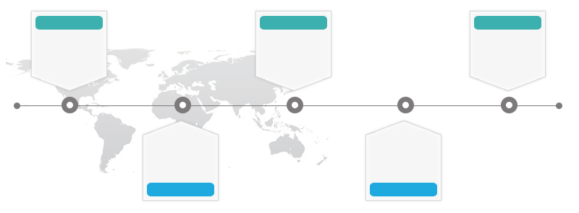
Associate Ops Manager with Cognizant Infrastructure Service

2016-2017

Network Engineer-Services with ECI Telecom
2011

2010-2011

Associate Telecom Engineer with Tata Communications

2011-2016

Program Manager
with TATA Communications

2017-2018

Delivery Manager with Vodafone India Services

 | Education |  | - Bachelor of Engineering (E&TC) from Pune University (RSCOE) in 2008
 | Certifications |  | - CCNA Course  - ITIL Foundation Certification (1302#311775547)  - PMP Certified (2038816; Valid-15 May 2020)
 | Work Experience
 | Jan'17-July’18 |  |  | Delivery Manager  Vodafone India Services Private Ltd., Pune  Directed the IT Project Operations including new platforms & services set-up across 3 Vodafone IT Service Datacenters  Significant Highlights:  - Successfully led all projects through aggressive project governance processes; developed relationships with business stakeholders and leadership teams; presented changes, issues, risks and contingency plans to balance project resources, schedules and scope  - Delivered large-scale, complex programs on IP backbone, Global Data Centers for Vodafone Group and Vodafone Local operating companies worldwide, with a focus on technology transformation, business risks and optimized costs  - Collaborated with leadership teams to evaluate technology challenges and led requirement analysis of IT Infrastructure & Telecom Network Demands raised by Vodafone Group and Local Markets (23+)  - Defined, and developed the Product & IT Roadmaps to highlight key milestones while creating project deliverables and defining requirements, scope, duration and cost of projects with European entities  - Ensured operational excellence by diligently administering key activities related to release, change, incident, service request, problem management, security validation, change management and risk control  - Spearheaded planning & budgeting of IT Infrastructure Operations, control of operational and capital costs, service/solution transition, market roll-out, service delivery, and in-life continuous service improvements activities
 | Jun'16-Jan'17  Highlights: |  |  | Associate Operation Manager  Cognizant Infrastructure Services (Trizetto), Pune  Significant Highlights:  - Led major change management projects including managing & controlling maintenance weekend for Production & Non-production Infrastructure Environment Month-on-Month basis  - Ensured the change function is integrated into relevant IT processes & procedures, utilizing best practice and industry standard frameworks to support business objectives
 | Dec'11-Jun'16  Key Projects: |  |  | Program Manager  TATA Communications, Pune  Significant Highlights:  - Spearheaded large-scale program for BW VPN, ILL, IPL, NDE, NLD Ethernet Solutions & Data Enters Colocations Services for platinum customer like EoSDH, SDH, DWDM technology for managed/unmanaged products  - Headed a team of 5 to effectively manage project operations with key focus on defining Service Level Agreements (SLAs) & Standard Operating Procedures (SOPs) as well as interacting with prestigious clients, business partners, industry leaders, vendors & other key stakeholders  - Led end-to-end circuit delivery including unmanaged & managed solutions, leveraging wireless solutions like Wimax. Radwin, and UBR PMP  - Created effective solutions specifically tailored to customer accounts such as Telephonica, T- Systems, Sprint & Idea and High BW Internet Customers like Atria, Beam, BBNL and Excell Media
 | Jan'11-Dec'11 |  |  | Network Engineer-Services with ECI Telecom (Macvin Consultancy), Pune  Planned & implemented 3G MPLS project for Idea Cellular & Vodafone. Integrated new Ethernet Technology introduced by ECI for faster data traffic & BW utilization.
 | Jan'10-Jan'11 |  |  | Associate Telecom Engineer with Tata Communications, Pune  Actively participated in new links/services built-up, testing & customer handover for EoSDH, SDH solution.
 | Personal Details |  |  | Date of Birth: 14th June 1987

